


Programme: BSc Applied Computing Level: 1
Module and Module Code: UFCF7R-30-1 Database Design UWE Credit Rating: 30
Module Leader: Jack Cole

Assessment Component: Component B
Assessment Type: Project Portfolio Word Count/Duration: NA

Submission Details: Please see assessment plan for hand-in dates
Submission Method: MS Teams - Assignment Upload
Feedback Due Within: 20 working days

Assignment Title: SQL Database Project
This assignment covers 60% of the assessment for this unit

LEARNING OUTCOMES COVERED IN THIS ASSIGNMENT
Learning Outcome
Learning outcome 1:
Design a complex database that employs data relationships, constraints and ownership. (Component B, element 1)

Learning outcome 2:
Optimise a database to reduce redundancies and data handling anomalies via Normalization (Component B, element 1)

Learning outcome 3:
Explain database relationships, ownership and constraints with a Database Dictionary (Component B, element 1)

Learning outcome 4:
Plan, design, implement and test a Database solution using appropriate tools. (Component B, element 1)

Format: See the programme and module guides for further guidance as to the standard format for this type of assessment.
Note: Students’ attention is drawn to the penalties attached to any form of assessment offence. In completing the assessment front sheet you are declaring that the work is entirely your own. References used in the assignment must be referenced according to the UWE Harvard System, as outlined in the Library Services’ iSkillZone (http://iskillzone.uwe.ac.uk/RenderPages/RenderHomePage.aspx).

Marking guide:

Grade | Descriptions
90-100% | Meeting all of the requirements for the 89.9% mark and in addition demonstrating a creative and unique synthesis of ideas and concepts including an evaluation of the methodological approach adopted
83-89.9% | Comprehensive coverage of all criteria for assessment, all of which have been explicitly interpreted. Extensive interrelating of alternative viewpoints or resources with the development of novel or original ideas and in depth reflection. Access to, and judicious selection from, a wide range of sources, many of which are original. Analysis and evaluation clearly and appropriately expressed demonstrating a confident integration of appropriate ideas and concepts in a succinct and elegant manner. Opportunities taken to refer to and engage critically with module learning outcomes and their implications as appropriate to the submission. The work demonstrates the student's ability to engage with appropriate dimensions of genre and discourse
76-82.9% | Comprehensive coverage of all criteria for assessment, many of which have been explicitly interpreted. Extensive interrelating of alternative viewpoints or resources with the introduction of novel or original ideas and in depth reflection. Access to, and judicious selection from, a wide range of sources, many of which are original. Analysis and evaluation clearly and appropriately expressed and a confident discussion of ideas and texts is demonstrated. Opportunities taken to refer to and engage critically with module learning outcomes.
70-75.9% | Comprehensive coverage of all criteria for assessment, many of which have been explicitly interpreted. Extensive interrelating of alternative viewpoints or resources with abundant evidence of reflection. Access to, and judicious selection from, a wide range of sources, many of which are original. Analysis and evaluation clearly and appropriately expressed. Opportunities taken to refer to and engage critically with module learning outcomes.
67-69.9% | Extensive coverage of all criteria for assessment with sound interpretation apparent. Main issues or principles are clearly elaborated in clear, cogent and reflective argument. A good range of sources utilised and the use of primary sources is prioritised. Good analysis and evaluation, coherently and fluently expressed demonstrating a scholarly presentation of ideas and an astute sense of audience. Opportunities taken to refer to module learning outcomes.
63-66.9% | Extensive coverage of all criteria for assessment with some interpretation apparent. Main issues or principles clearly elaborated and with creditable degree of reflection. A good range of sources utilised, with some being original. Good analysis and evaluation, coherently and fluently expressed. Opportunities taken to refer to module learning outcomes.
60-62.9% | Coverage of all criteria for assessment with some interpretation apparent. Main issues or principles clearly elaborated and with creditable degree of reflection. A good range of sources utilised, with some being original. Good analysis and evaluation, coherently and fluently expressed. Opportunities taken to refer to module learning outcomes.
57-59.9% | Largely relevant coverage of the criteria for assessment with the main issues or principles identified explicitly. A satisfactory level of reflectivity upon a range of sources, all relevant but mostly secondary. Analysis and/or evaluation attempted with success. Module learning outcomes acknowledged with some implications reviewed.
54-56.9% | Largely relevant coverage of the criteria for assessment with the main issues or principles identified explicitly. A satisfactory level of reflectivity upon a range of sources, all relevant but mostly secondary. Analysis and/or evaluation attempted with moderate success. Module learning outcomes acknowledged with some implications reviewed.
50-53.9% | Largely relevant coverage of the main criteria for assessment and a satisfactory level of reflectivity upon a range of sources that are largely relevant but mostly secondary. Some attempt at analysis with moderate success. Module learning outcomes acknowledged and some implications reviewed.
47-49.9% | Adequate relevant coverage of the criteria for assessment with some development of the criteria but little interpretation apparent. Some irrelevance and/or inaccuracies in the selection of content. Reflection apparent with beginning of development but erratic analysis and evaluation. Level of study insular.
44-46.9% | Adequate relevant coverage of the main criteria for assessment. Some irrelevance and/or inaccuracies in the selection of content. Reflection apparent but minimal analysis and evaluation. Module learning outcomes referred to appropriately. Level of study insular.
40-43.9% | Barely satisfactory coverage of the criteria for assessment with a substantial degree of irrelevance and inaccuracy apparent. Reflectivity acknowledged but lacking substance. Little analysis and evaluation. Use of secondary sources only and little more than acknowledgment of the module learning outcomes.
Fail

35-39.9% | Unsatisfactory coverage of the criteria for assessment with a substantial degree of irrelevance and inaccuracy apparent. Reflectivity acknowledged but lacking in substance. A marked absence of analysis and evaluation. Use of secondary sources only and little acknowledgement of the module learning outcomes.
28-34.9% | Failure to meet most of the stated criteria with the work largely irrelevant to the assignment set. Inappropriate reference to the literature and/or relevant experience.
1-27.9% | Failure to meet most of the stated criteria with the work largely irrelevant to the assignment set. Inappropriate reference to the literature and/or relevant experience.
0% | Failure through non-submission.

Marking criteria and distribution:
The following table outlines the weighting on specific tasks/learning outcome. Please ensure any word counts correlate in accordance with percentage weighting.
Learning  Outcome | Criteria | Related Task | Percentage Weighting
1 | Design a complex database that employs data relationships, constraints and ownership. | 1/2 | 60%
2 | Optimise a database to reduce redundancies and data handling anomalies via Normalization | 1 | 10%
3 | Explain database relationships, ownership and constraints with a Database Dictionary | 1 | 10%
4 | Plan, design, implement and test a Database solution using appropriate tools. | 2/3 | 20%

Please note that marking/grades will consider the following:
- Academic writing skills.
- Range of referenced materials used.
- Correctness and accuracy of UWE Harvard referencing.
- Presentation of content and structure.
- Presentation skills (Presentations only).

Assignment Introduction:
You are working for an application development company who have been tasked with developing a staff management platform for the New Hinckley Point Reactor G.

Before you start
When building JOINS remember to look for the foreign keys and tackle them one join at a time.
When building queries for the parts listed below you will be given the column_name aliases to use. This is because the php code uses the aliases you will be provided with.

Prepare the database
You will need to create a database called "SAD" and import the supplied SQL files found in the sql_data directory. Finally using the graph below you need to create the table called "work_schedule" and build the connections depicted (foreign keys):
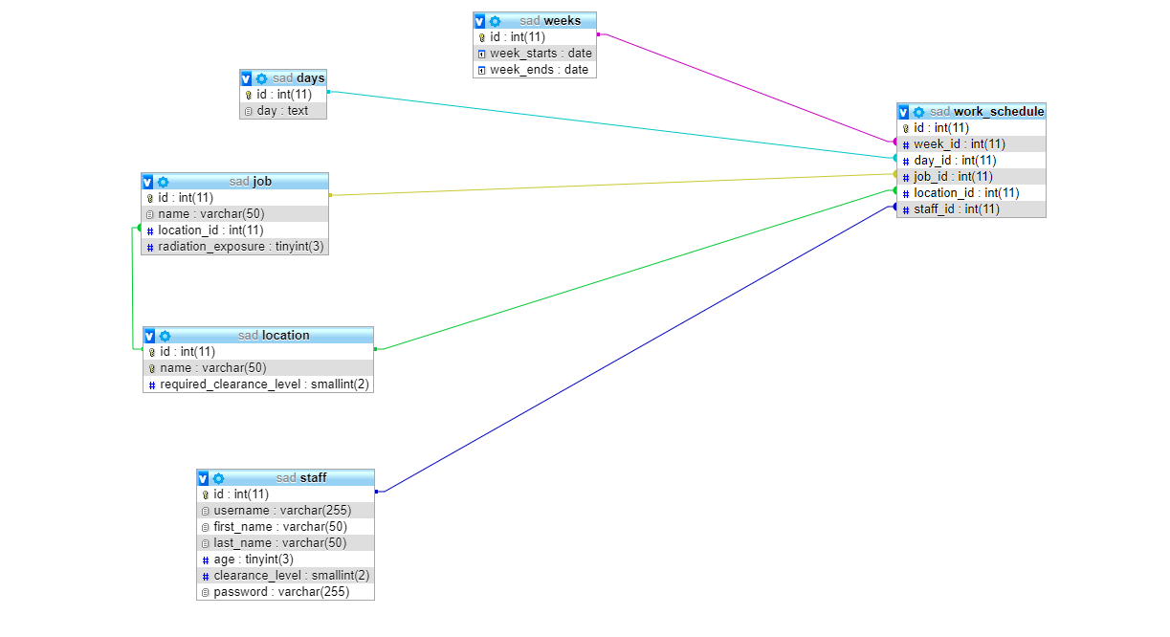

Practical Assessment Tasks

Prepare the system

Part 1: _connect.php line 6 Make sure this file can connect to the SAD database.

Enable the login system

Part 2: _auth.php line 23 You need to use $username and $password from above to find a matching staff member.

Activate the admin system

Part 3: utlis.php line 17 Starting from work_schedule, use JOINS to gather the required data from:
- work_schedule
- staff
- job
- location
You will need to use the php variables $week and $day in your WHERE clause to ensure you collect the appropriate data.

Part 4: staff_raditaion_exposure.php line 37 Starting from work_schedule, use JOINS to gather the required data from:
- staff
- job
The query will need to calculate (SUM) the total amount of radiation exposure staff members are exposed to. The query requires JOINS and it is a good idea to start from the work_schedule table
You are supplied with the WHERE clause stored within a php variable $staff_check, you will NEED to use this in you your query.
You will also need to GROUP BY staff.id
Ordering by exposure levels would be nice touch :)

Part 5: delete_work_schedule.php line 11 Create a SQL query that can DELETE a work_schedule entry based on the php variable $id

Part 6: utils.php line 120 Create a query to SELECT the listed data from the staff table.

Part 7: utils.php line 138 Create a query to SELECT the listed data from the job and location tables, you will need to use JOINS.

Part 8: utils.php line 163 Create a query to SELECT the listed data from weeks.

Part 9: utils.php line 178 Create a query to SELECT the listed data from days.

Part 10: appoint_job.php line 21 You need to create an INSERT query here to create a new work_schedule based on the provided php variables:
- $work_week_id
- $work_day_id
- $work_staff_id
To acquire the location_id you will need to create a nested SELECT query using the php variable $work_job_id.

Part 11: edit_job_appointment.php line 19 You need to create an UPDATE query here to edit a work_schedule based on the provided php variables:
- $work_week_id
- $work_day_id
- $work_staff_id
To acquire the location_id you will need to create a nested SELECT query using the php variable $work_job_id.
Make sure you use the $appointment_id from line 8 in your WHERE clause.

Part 12: utils.php line 191 Create a query to SELECT a work_schedule entry based on the id. Make sure to use the php variable $id in the WHERE clause.

Part 13: staff_schedule.php line 11 Make sure you use $staff_id variable in your WHERE clause to SELECT staff member based on ID and select the required data.

Part 14: staff_schedule.php line 35 Starting from work_schedule, use JOINS to gather the required data from:
- work_schedule
- staff
- job
- location
- weeks
- days
You will need to use the php variable $staff_id in your WHERE clause to select WHERE staff.id = '$staff_id'.

Assignment Tasks:
For this assignment, you are required to complete the following tasks:

Task 1- Design Documentation (20%)
You must design your proposed solution to the business problem presented within the introduction above. Please ensure you provide:
Data Dictionary
Entity Relationship Diagram
Level 0 DFD

Task 2- Implementation (60%)
Using MySQL, implement a relational database which meets the requirements set out within the assignment introduction (above). You will be provided with the PHP for the system, you will need to look at developing the SQL to allow for this to work.
Through-out the implementation of the system, the normalisation process should be followed, you should ensure that:
- The database is fully relational, containing relevant primary, foreign and composite keys, with suitable relationships being formed between the entities.
- Correct implementation of SQL data types and validation (e.g. field sizes)
- Sample data entry
Please note: You should ensure that you follow good industry standards when creating the database, as this will be used as part of the assessing criteria.

When task 3 has been completed, you should fully export and submit the database file itself, along with the PHP and SQL website files which have been developed.

Task 3 – Database Reports (20%)
Management have asked you to design a reports page (reports.php) to monitor staff and work allocation. The design/type of queries are left to you but must be justified in your source code. Tables, graphs and/or charts should be used to present data.
Examples could include
- Numbers of jobs allocated to each staff member
- Staff listing by total radiation
- Show staff with no work allocated
- Task schedule, listed by reactor
Three complex queries must be used, each using at least two database tables.

Key Assessment Notes:
- All referenced material MUST be provided within a reference page at the bottom of the task 1 report document.
- For tasks 3 and 4, marks will be awarded for use of best coding practices and industry techniques e.g. data validation rules, naming considerations and any additional content.
- This assignment focuses solely on the SQL back-end of the system, any additional UI scripts and designs such as using HTML or PHP will not be required for this assignment. The main aim is to create a back-end database system that could be implemented into a front-end system in the future.

Additional Recommended Reading/resources:
Please refer to the module handbook for full recommended reading

UWE Online Library - http://www1.uwe.ac.uk/library/

